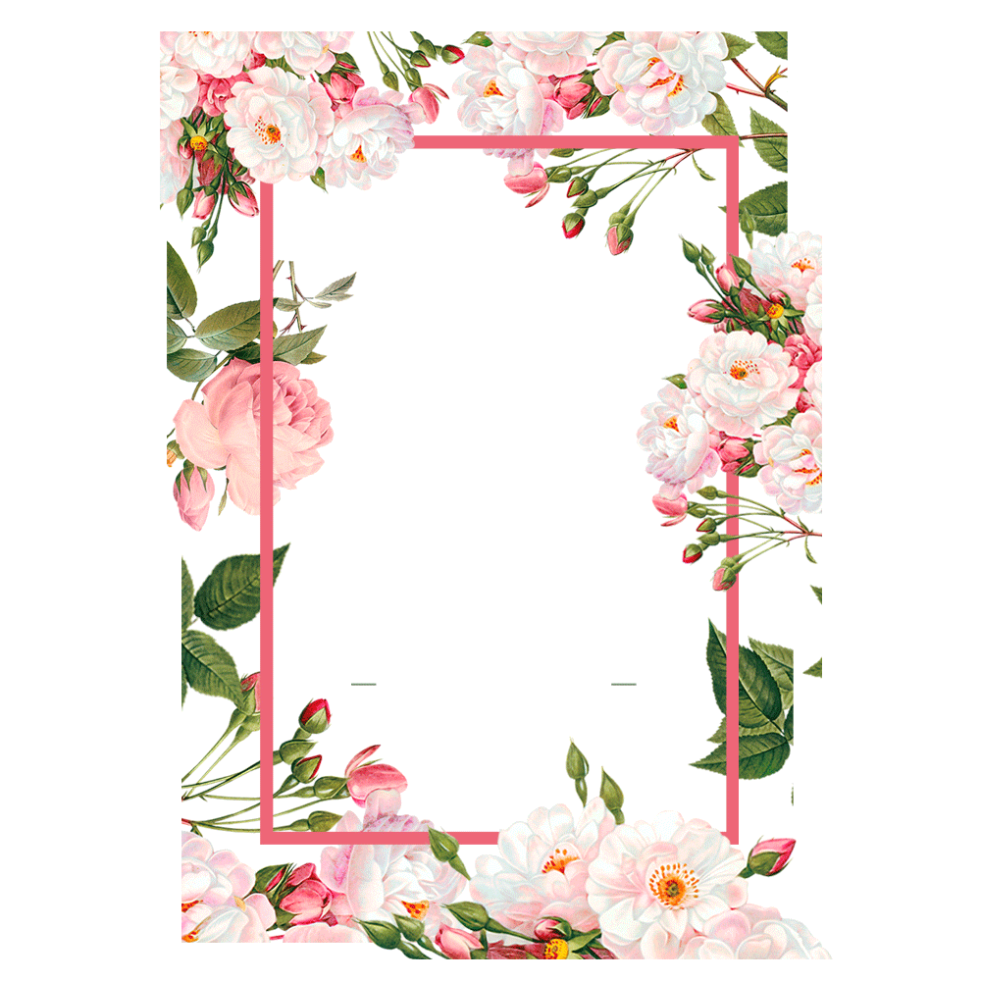o

Cream Tea £7 pp

A homemade buttermilk scone served with clotted cream and

strawberry jam with a pot of tea or coffee – the classic

Afternoon tea - £18.95 pp

**Top Tier**

Individual Lemon Drizzle Cake, Italian Meringue, Candied Lemon

White Chocolate & Raspberry Cheesecake, Mango & Passionfruit Jelly

Individual Duo of Chocolate Tart, Raspberry Marshmallow

**Middle Tier**

Our Homemade Buttermilk Scones with Dorset Clotted Cream & Strawberry Jam

**Bottom Tier**

Sandwiches

Smoked Salmon, cream cheese & watercress

Confit beef, horseradish & watercress

Cheese Savoury

High Tea - £21.95 pp

Includes a full afternoon tea plus

Pork, sage & black pudding sausage roll, toasted black onion seeds

Pork, apple & thyme scotch egg, soft egg.

Wild Mushroom & Black Truffle Tartlet, Puff Pastry

Any dietary requirements must be notified at time of booking

(24 hours’ notice is needed when booking our Afternoon tea or High Tea )

**\*\*Please speak to our staff about the ingredients in your meal, before placing your order.**

**\*\*A 10% (Optional) Service charge will be added to your final bill**